**Mini-project Computer Graphics**

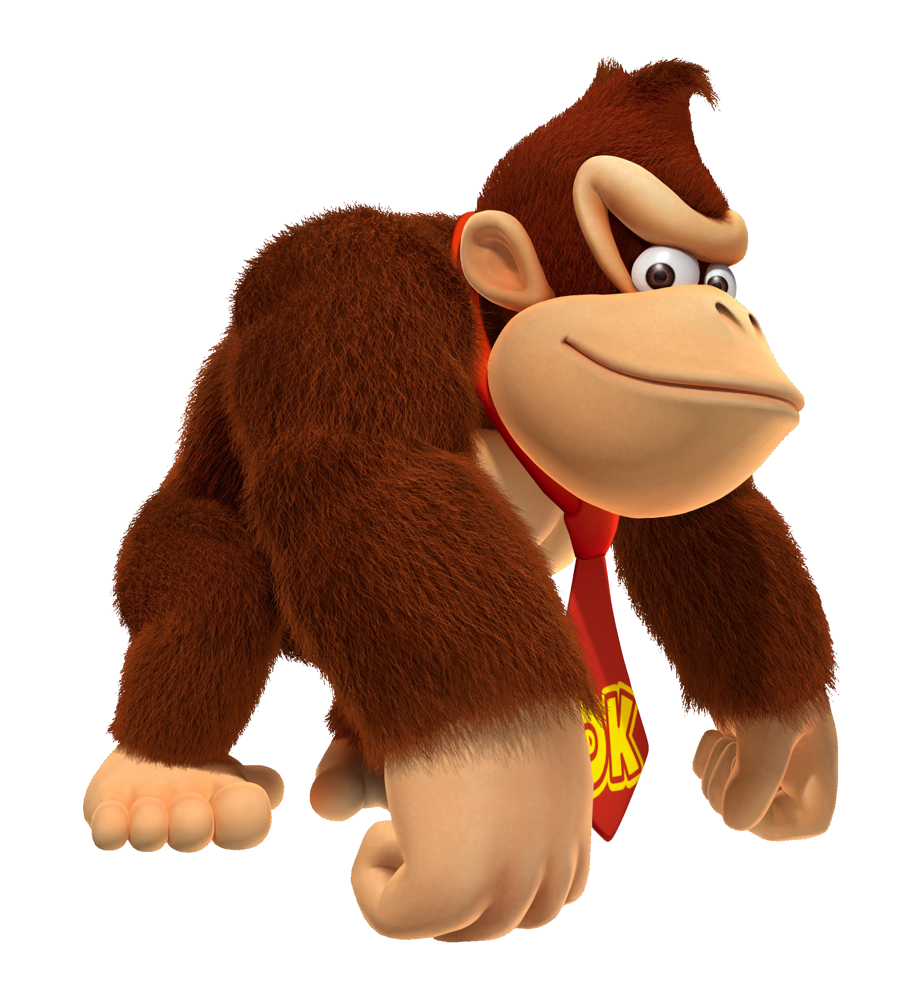

*Group 6 – Donkey Kong*

Jarco de Jong

Laurens Weijs

Mats Mulder

# Group members:

Jarco de Jong - jarco1995@hotmail.com

Laurens Weijs - Laurensweijs@gmail.com

Mats Mulder – [Mats.Mulder@live.nl](mailto:Mats.Mulder@live.nl)

# Game description:

# Game controls:

|  |  |
| --- | --- |
| Arrow Left | Move Mario to the left |
| Arrow Right | Move Mario to the right |
| Arrow up | Move Mario up on ladder |
| Arrow down | Move Mario down on ladder |
| Spacebar | Jump |
| Double spacebar | Double jump |
| P | PauseMenu |

# Externel assets used: